WP7 Strategy Documents
Deliverable 7.1 Strategy for exploitation
Deliverable 7.4 Strategy for dissemination
Deliverable 7.8 Strategy for communication
Report No. D7.1, D7.4, D7.8 / Date: 30/03/2021

Røyrvik, J., Nilsen, B.T, Norderhaug, E.M. S., Bugge, G.

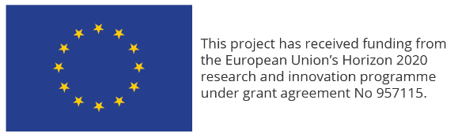
ENCHANT Report
WP7 Strategy Documents
KEYWORDS  - Exploitation  - Dissemination  - Communication | VERSION  02 |  | DATE  30.03.2021
AUTHOR(S)
Røyrvik, Jens (NTNU SR), Nilsen, Berit Therese (NTNU SR), Norderhaug, Egil Martin S. (VIKEN), Bugge, Guri (VIKEN)

QUALITY ENSURANCE
Andrea Kollmann – Kirsten Sink

 | PROJECT NO.  957115 (H2020) |  | NUMBER of PAGES/APPENDICES:  32/0
ABSTRACT
This report is an internal working document for ENCHANT outlining the various dissemination, exploitation and communication activities planned for the project, as well as coordinating and linking efforts in an encompassing strategy across partners and WPs. To reach ENCHANT’s objectives, and collect data informing our research questions, dissemination, exploitation and communication are core elements. The report serves as a strategic document to coordinate dissemination, exploitation and communication efforts internally in the project between partners, and externally to relevant audiences. The report is an internal working document for ENCHANT which outlines the different types of activities and initiatives, how they are linked to each other, to the ENCHANT objectives, and research questions.
REPORT NO.  D7.1, D7.4, D7.8 | ISBN  N/A | CLASSIFICATION  public | CLASSIFICATION THIS PAGE  public
DOCUMENT HISTORY:
VERSION | DATE | VERSION DESCRIPTION
1 | 10.03.2021 | First version for quality check
2 | 30.03.2021 | Final version delivered to the European Commission

Disclaimer
The opinions expressed in this document reflect only the authors’ view and reflect in no way the European Commission’s opinions. The European Commission is not responsible for any use that may be made of the information it contains.

Table of contents
1. Introduction 6
1.1. About ENCHANT 6
1.2. Responsibility and ownership 8
1.3. Organisation 9
2. Exploitation strategy 11
2.1. Objectives 11
2.2. Key exploitable results (ER) 11
2.3. Potential beneficiaries of ENCHANT’ research results 13
2.4. Characterising project results and partners’ expectations 14
2.5. IPR management 14
2.6. Business Plan 15
2.7. KPIs 16
3. Dissemination strategy 17
3.1. User Partner Network 17
3.1.1. Webinars 17
3.2. Workshops 18
3.3. Developing and disseminating the ENCHANT tool 18
3.4. External events 19
3.4.1. Scientific dissemination 20
3.4.2. Liaison with related EU-funded projects 22
3.5. Key Performance Indicators (KPIs) 22
4. Communication strategy 24
4.1. External communication 24
4.1.1. Cooperation and communication with external projects 25
4.2. Internal communication 25
4.3. Key Performance Indicators 27
4.4. Stakeholders and target groups 27
4.5. ENCHANTING Tuesday 28
4.6. Website and social media 28
4.6.1. Social media 29
4.6.2. Content production 29
4.7. User partner’s and other communication channels 29
4.7.1. Channels we do not control 30
4.8. Corporate identity 30
4.8.1. Layout, logos and guidelines 30
4.8.2. Acknowledge EU Funding: 31
4.8.3. Basic rules for layout: 31
4.9. Distribution of responsibilities 32
4.10. Message and terms 32

Introduction
This document lays out the dissemination, exploitation and communication strategies (DEC Strategies in the following) of the ENCHANT project. Its purpose is to coordinate ENCHANT DEC activities in order to strengthen the overall impact of the project and ensure a quick and widespread uptake of its results.
The DEC Strategies are structured as follows. Starting with the definition of ENCHANT DEC objectives the DEC Strategies document defines the overall approach to project exploitation, dissemination and communication. It further specifies the project’s target audiences and identifies key messages to be conveyed to them. It continues by describing ENCHANT tactics, including exploitation and dissemination activities to be conducted and communication channels to be used. Finally, it outlines partners’ roles in the implementation of DEC activities, introduces related KPIs and explains the procedures for their monitoring and evaluation. The structure in the report follows the order of deliverables, starting with exploitation, before dissemination and at last communication.
The DEC Strategies are developed under Tasks 7.1 and 7.2 (lead by partner NTNU SR), and Task 7.3 (lead by partner Viken) of Work Package 7. It draws on the project’s Description of Action and incorporates input from all project partners. The DEC Strategies functions as a living document. Updates of this document will be submitted to the EC in months 14, 24, and 30.

About ENCHANT
The climate pact the new European Commission is driving forward is setting explicit and ambitious goals for deeply decarbonizing European lifestyles and economies. To reach these goals, all means of reducing energy demand need to be fully exploited. This puts the focus on energy efficiency understood as an energy source in its own right as an important pillar of the Energy Transition. According to Eurostat, private households are responsible for 27% of all primary energy use, not including energy embedded in products and services consumed by households. This makes energy efficiency improvements in households an important target for interventions. Behavioural science has made great progress in developing intervention tools and programmes to improve energy efficiency in this sector, but almost all of the studies in this area are based on small-scale pilot studies. To have a measurable effect on the European scale, the applicability of such programs in real-life, cost-efficient, and practical settings is still an open issue. The most important question to answer is which (combination of) intervention tools are the most effective one to be implemented by which societal actor and in which cultural context. ENCHANT will address this knowledge gap.
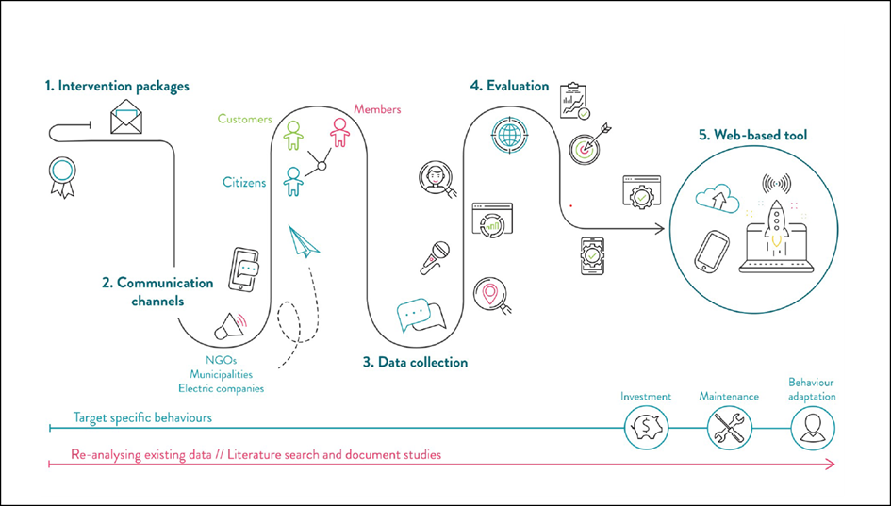
Figure 1 Core concept of ENCHANT
ENCHANT is contributing to reducing GHG emissions by applying existing knowledge of interventions to increase energy efficiency in European households by implementing these interventions on an unprecedented scale and pace, thereby bridging the gap from knowledge to impact.
ENCHANT will use a Randomized Control Trial (RCT) approach. Interventions will be developed, fitted, and tested with the objective to unlock the energy efficiency potential in the general public, through behavioural change. Including a large group of user partners (energy providers, municipalities, environmental organizations), ENCHANT provides the intervention tools through existing communication channels and thus tests their effects in real life. Through a systematic evaluation of data gathered from this testing, in combination with re-analysing already existing data, ENCHANT will design an empirically informed decision tool for impactful energy-efficiency campaign design, relevant for a number of actors, like policymakers, municipalities, NGOs, and energy providers.
ENCHANT is a project within the Horizon 2020-program. Projects that are funded by the EU must comply with EU directives on information, communication and the principle of openness. In line with this, the directives issued by Horizon 2020 regarding communication and information are followed.
Use of terms
- The name of the European Union should always be spelled out in full.
- We use the term consortium for the formal partners that make up the project ENCHANT.
- We use the term Coordinator, which is NTNU.
- We use the terms project owner or national coordinator.
- Within the project, the various parts are called Work Package /WP and the person in charge is called the WP-leader.
- Within the project, the term task is used for the various tasks in the project. The person in charge is called the task leader.
- We use the term partner for participating academic institutions, companies, municipalities, counties and organizations in the project.
- We use the term academic partner for the academic/research partners, and user partner for the non-academic partners in the consortium.

Responsibility and ownership
NTNU is Coordinator and the following partners are participating in the project:
User partners | Academic partners
- Viken fylkeskommune - Norway  - Naturvernforbundet – Norway  - Izmir Metropolitan Municipality - Turkey  - Gediz Elektrik Perakende Satis AS - Turkey  - Energie Kompass - Austria  - Fondazione Roffredo Caetani - Italy  - Energia Positiva - Italy  - Electrica - Romania  - Cluj-Napoca Municipality - Romania  - Asociatia Centrul pentru Studiul Democratiei - Romania  - Badenova - Germany | - NTNU - Norway  - Roma Tre University - Italy  - Izmir University of Economics - Turkey  - Babes-Bolvai-University - Romania  - Energy Institute at the Johannes Kepler University Linz - Austria  - Smart Innovation Norway - Norway  - NTNU Social Research – Norway

All partners, user partners as well as academic partners in the consortium, are participating in the research activities. User partners are responsible for communication activities regarding interventions.
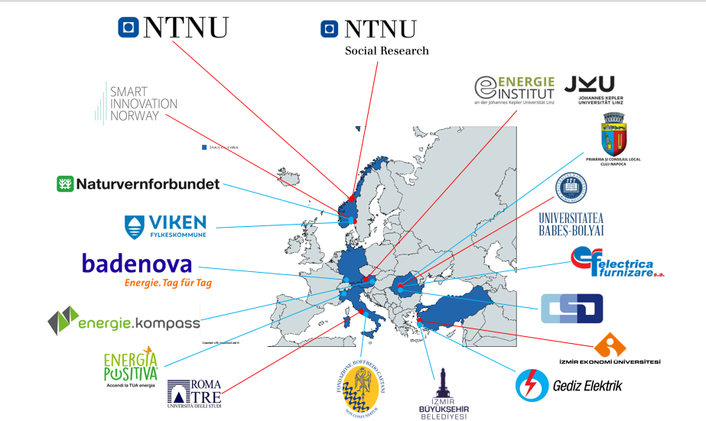
Figure 2 Partners in Enchant

Organisation
The project is organized in four phases, and seven work packages.
Phase I: Developing
The first phase is concerned with identifying and developing the interventions. It comprises WP2 and WP3. WP2 identifies key factors affecting intervention impact on energy behaviour. It also designs the intervention packages and defines the main independent variables. WP3 informs WP2 by making an inventory of all relevant datasets in addition to conducting a data review to inform the intervention packages and the pilot implementation.
Phase II: Testing and implementing
The second phase is about testing and implementing the intervention packages. WP4 is the central component in this phase. WP4 implements the intervention packages developed in WPs 2 and 3. In doing so, the intervention packages will be fine-tuned with the development of operational plans and establishment of monitoring mechanisms for impact assessment.

Phase III: Evaluating
Phase three of ENCHANT concerns evaluating the interventions implemented in WP4, which is primarily done by WP5. WP5 will establish KPIs related to the impact categories. It further assesses the impact of the tested interventions, as well as their replicability, upscalability, and their limitations. It also identifies barriers and success factors for the transfer of best practice.
Phase IV: Utilising and disseminating
The last phase of the project’s primary concern is with the dissemination of findings and with developing a policy instrument matrix/tool. The tool will be available in two versions; one web-based ‘light’ version and one full version with options for more detailed information and customization.

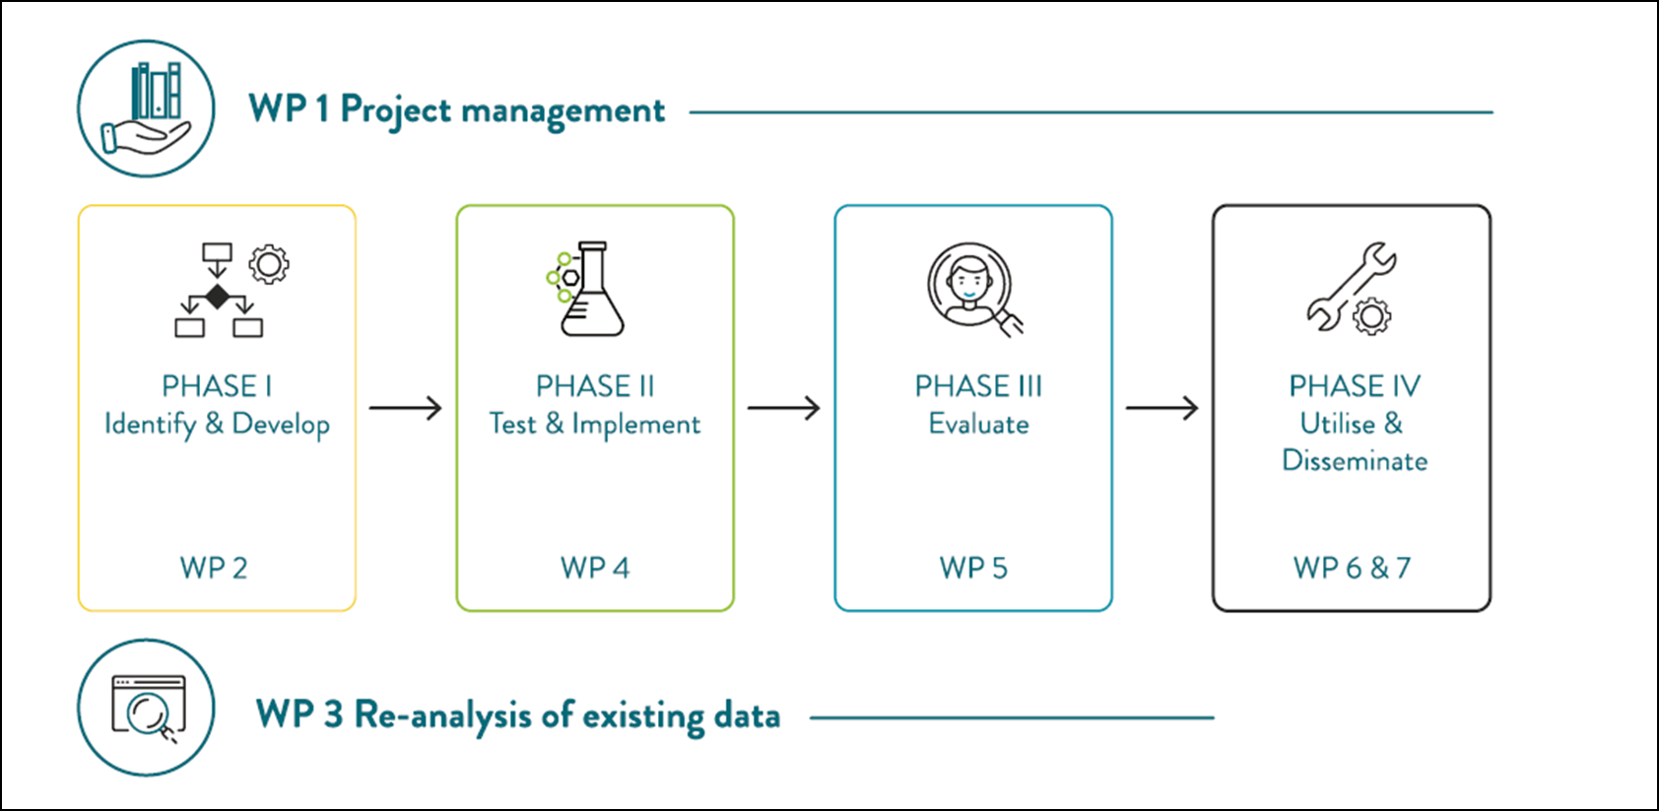
Figure 3 Project organisation

Exploitation strategy
Doing trials on such a massive scale and under real life conditions has rarely been done, and it places ENCHANT at the forefront of research. This means the project is likely to get novel empirical and analytical results that are suitable for exploitation.
The development of a detailed exploitation and business plan, as well as exploitation-dependent dissemination activities, will protect the exploitation interest of all 18 partners. Each partner contributes with their own knowledge and has a specific role in the development and further exploitation of the results of the ENCHANT project, as will be further detailed in this section.
In the final phase of the project, the exploitation plan of this project will advance to a stage in which the knowledge generated in the project might be exploited at a large scale by the project participants themselves or might be attractive for other entities outside the consortium.

Objectives
The main objective of this section is to provide insight into the first steps taken to develop the strategy for the exploitation of ENCHANT’ results. It provides the guidelines to build the strategic exploitation plan and, although the exploitation of results is expected to start in relation to Milestone 3, the first results of preparing this process are reported here. The exploitation plan furthermore identifies the key exploitable results (ER) and the potential beneficiaries, determines the concrete business plan, and analyses associated IPR issues, as well as potential risks.

Key exploitable results
The ENCHANT projects will produce a number of results, and the key exploitable results are those which, 1) can formally be utilized on the basis of the CA of the project, and 2) the consortium sees a potential for exploitation in. In the proposal stage, the consortium defined a first list of main project results, taking into account the project objectives and expected outcomes. This information now constitutes the baseline and will be updated throughout the project, according to the research results, the partners’ expectations and contributions.
ENCHANT will develop an empirically informed decision tool for impactful campaign design targeting energy-efficiency, which will be presented in two versions. The ‘light version’ will be made available online, and will be readily accessible, useful for easy adaptions and will provide options for customizing the content to some extent. The full version (where the format is still to be decided), will provide much more detailed information and can be customized to each user category in detail. This version of the tool can also be applied commercially, for providing energy behaviour analysis and will likely come with a related workshop concept.
ENCHANT’s main results rely largely on the data sets generated in the project, as shown in the table underneath. Some of the data can be exploited by the individual user partner, but will not be accessible for other parties without explicit consent.
Table 1. ENCHANT key exploitable results (ER 1-10)
Category | Project results | ID
Data | Raw data from user partners | ER1
 | Survey | ER2
 | Interview data | ER3
 | Consumption data | ER4
Analytical results | Effect evaluation of interventions/technology/context | ER5
 | Demonstrated real life effects | ER6
Tools and recommendations | ‘Light version’ of tool | ER7
 | Full version of tool | ER8
 | Recommendations of intervention design. | ER9
 | Developing user- and academic partners’ competence. | ER10

Each partner, and the ENCHANT consortium as a whole, will evaluate direct or indirect forms of exploiting the project results. At this stage, the list underneath presents the pathways for exploiting the results:
Pathways for exploiting results in ENCHANT
- Scientific publications under the green or gold open access scheme
- Action plans for municipalities energy companies and NGOs involved in energy transition strategies
- Data on user preferences and user-centred strategies for utilities and other commercial agents in the energy field
- Webinar concept for developing competence in interested user- and academic partners
- Broad implementation of the light version of the tool online
- Applying the tool as a commercial opportunity for analysis.

Task 7.1 will develop a more detailed and context-sensitive plan for exploiting ENCHANT results, where different possible and anticipated routes for exploitation are described. This will specify for each ER, and each partner, which routes are available.

Potential beneficiaries of ENCHANT’ research results
One of the main objectives of ENCHANT is to contribute to policy-making, supporting the advance towards the Energy Union and the implementation of the revised SET Plan. Therefore, policymakers constitute one of the main groups of beneficiaries of ENCHANT. Although ENCHANT gives priority to policy requirements, the project will also address other relevant issues such as research, societal and market needs and, thus, its benefits will reach a wider range of stakeholders.
Policymakers
- European Commission & European Parliament
- National, regional and local authorities
  - National SET-Plan representatives
  - National Regulatory Authorities
  - EU Regions
  - Municipalities
- Regulatory Entities/Agencies

Scientific community
- Energy-related behavioural research community
- Energy economics research community
- Energy research community
- Social science research community

Industrial and commercial community
- Energy companies
- Distribution System Operators
- Transmission System Operators
- Utilities
- Renewable energy generators
- Media
- Energy saving consulting companies

Public
- Energy efficiency agencies
- Environmental NGOs
- Energy cooperatives and associations
- Consumer organisations
- Citizens’ organisations
- Individual citizens

These beneficiaries are also stakeholders and form part of ENCHANT’ target audience in terms of dissemination and communication activities, as described in the following chapters.

Characterising project results and partners’ expectations
Once the key exploitation results have been refined, the project team will gather information on a number of aspects described below and develop a characterisation table for each asset.
Characterisation for each asset
- Description of the project exploitation results and their respective potential beneficiaries
  - Short description of the result
  - The innovativeness it introduces compared to existing research/solutions/services
  - Description of potential beneficiaries or stakeholders
- Identification of the lead partner and the contributors for each exploitable result: A lead partner will coordinate the exploitation for each individual result, focusing on the identification of the preferred routes for exploitation.
- Partners’ expectations: the partners involved in the development of each project result will describe their intended routes for exploitation of those results.

During the next ENCHANT General Assembly (22-24 Feb 2022), a first exploitation workshop will be organised to confirm or modify the preliminary identification of project results and to work on their characterisation and the partners’ expectations.

IPR management
The Consortium Agreement (CA) established strict rules for the management of IPR and includes all provisions related to the management of IPR including ownership, protection and publication of knowledge, access rights to knowledge and pre-existing expertise as well as questions of confidentiality, liability and dispute settlement.
In the CA the Partners have identified the background knowledge included and excluded (Attachment 1 of the CA). Section 8 of the CA specifies the general principles governing ownership, transfer and dissemination of results, whereas Section 9 includes details on access rights.

Business Plan
The partners will develop the business plan for ENCHANT in the last stage of the project and this document will be complementary to the DEC Strategies. It will detail the commercial and non-commercial uses of the data produced in ENCHANT.
As previously described, the tool ENCHANT develops will be presented in two versions, where one is a light version available online, and the other version is more complex and can be customised to each user in detail. Particularly the full version tool can also be applied commercially, as a tool for providing energy behaviour analysis for organizations and companies.
We will arrange a workshop in relation to Milestone 3 (M21), where developing business plans is focus.
A basic business plan will include what is described in the following:
Business plan content

- The overview, institutional and operational framework of the specific service derived from the project
- The organisational structure, the roles and responsibilities of the partners
- The service production process
- The marketing policy
- The pricing policy
- The definition of the communication and marketing channels
- The economic and financial plan, if a commercial exploitation is sought
- The risk analysis
- The exit strategy

KPIs
KPIs will be further developed throughout the project. The initial exploitation KPIs are:
KPIs, exploitation
Number of exploitable results
Number of business plans
Number of beneficiaries (made use of the results).
Number of exploited results realised

Dissemination strategy
To reach ENCHANT’s main objectives of affecting energy behaviour in a more sustainable direction, a solid strategy for dissemination is critical. The consortium has already established a high-level strategy to disseminate the project’s findings and to engage stakeholders. This report aims to elaborate further this strategy before proceeding with its implementation. The dissemination strategy will be implemented through several subtasks.

User Partner Network
The networks formed by the project partners are key for dissemination activities in ENCHANT. Of the 18 partners, seven are academic with individual academic networks that combined span across Europe in a number of disciplines providing insights and cutting edge scientific knowledge on how to reduce our energy consumption. These networks, both individually, and combined, will be actively used when planning for and implementing ENCHANT’s dissemination strategy.
One of ENCHANT’s novelties, however, is the close collaboration not only between the academic partners, but also with the highly skilled and well-connected user partners. The 11 user partners represent skills, knowledge and experience regarding communicating and disseminating knowledge, information, encouragement to their target groups, and do themselves represent public stakeholders, like counties and municipalities, member organizations and interest groups, like NGOs, as well as private actors in the form of energy companies. The user partners are also very well connected, particularly in their local settings, both with other stakeholders in the same category as themselves, and across the public and private sector, including academic institutions.
In combination, therefore, the network is established both locally, regionally, nationally and internationally, which means ENCHANT has a unique position we plan to exploit with regard to disseminating our findings. ENCHANT has a complex set-up, meaning we will gather insights on a number of arenas in addition to the main objectives that are also useful for other stakeholders. This might include such elements as how to best adapt interventions to various contexts, or establish a trustworthy baseline, to experiences with different kinds of communication channels that others might find useful.

Webinars
One channel for disseminating findings and results across the entire, or parts of, the User Partner Network, is a series of ENCHANT webinars delivered by NTNU SR in the second half of the project. The series is called ‘Effects of real interventions in real contexts’ and while primarily targeting the User Partner Network, other participants will actively be encouraged to join.
The webinar series will present and share insights, findings and results from all stages of the ENCHANT project, and will be organized along the three phases presented in section 1.3, and tailored to disseminate what the three types of user partners suggest. While some webinars will be developed for a single group of user partners, others might be directed towards cases and places that have common challenges or solutions. Yet other webinars might be directed towards particular policies. Some might involve the whole network, disseminating findings that are relevant across actors, sectors and stakeholders.
We will start by organizing the webinars by user partner category, but will make adjustments if needed.

Workshops
Three types of workshops (WS) are planned in ENCHANT, and while all three will aid the project’s dissemination efforts, the Policy design WS will be particularly targeting dissemination outcomes.
- Steering group and consortium WS: these workshops will be organised as internal project activities, and make sure all partners have a shared understanding of methods and deliverables. They will follow up the various consortium members in their production and ensure that the project complies with its own Project Management Plan.
- User-partner WS: in WP 2 a series of participatory co-construction workshops, will be arranged to select and define the ENCHANT intervention matrix. These workshops will address various types of user-partners to discuss and identify practical implications, main infrastructures and existing or potential policy schemes.
Both the ‘Steering group and consortium WS’ and the ‘User-partner WS’ will inform the ‘Policy design WS’, which will contribute directly to disseminating finding to policy stakeholders in all seven countries participating in ENCHANT. In order to minimize GHG emissions, ENCHANT’s workshops will be mostly digital or a mix of locals meeting physically and non-locals joining virtually.

Developing and disseminating the ENCHANT tool
For the results from the real life testing of the various interventions to be available and applicable to other stakeholders and societal actors across Europe, one of the main dissemination results of ENCHANT is an easy-to-use planning tool (WP6). The decision-making tool’s basis is an adaptation of a recommender system, which is a technology based on machine learning identifying patterns within large data sets, matching desired states (in our case changes substantial in energy efficiency) with behavioural or demographic patterns in the population. In this tool, the empirical results will be developed to support policymakers, municipalities, NGOs and other collective social units promoting energy efficiency in selecting the most effective campaign design for their specific context and resource situation.
For the purpose of designing the recommender system, the tool will transfer data gathered from the work done with designing the intervention packages, re-analysing existing data, implementing and monitoring the pilots, as well as assessing impact and designing policy (WPs 2-5). The system will use an algorithm that will be developed and trained (in WP6), and validated by tests in the pilot environment. Further, the decision-making tool will be adjusted according to feedback and involvement from user-partners, to meet the needs of specific user groups.

External events
Participation in external events is a core dissemination channel of the ENCHANT project. To register this activity, all project partners will be asked to update a shared online spreadsheet, the ENCHANT Impact Tracker, each time they plan to – or have already disseminated ENCHANT results on external events. The partners will be reminded, and the tables will be updated, regularly.
The following table presents key events where project partners have already presented the project and its findings.
Table 1, Participation in external events
Partner | Event | Date | Where | Audiences
NTNU | Behavioural insights to inform energy policy / network meeting | 11.02.2021 | Virtual | Other EU projects, European Commission

This table presents key events where project partners plan to present the project and its findings.
Table 2, Planned participation in external events
Partner | Event | Date | Where | Audiences
NTNU, NSR, ROMA3, EI-JKU | ICEP conference (http://icep2021.com/) | 5-8.10. 2021 | Siracusa, Italy | Behaviour scientists

Scientific dissemination
An important outcome of the ENCHANT project will be the dissemination of its results through research articles in international peer-review journals. The initial list of relevant journals includes:
Academic journals | URL
Applied Energy | https://www.journals.elsevier.com/applied-energy
Energy | https://www.journals.elsevier.com/energy
Energy Conversion and Management | https://www.journals.elsevier.com/energy-conversion-and-management
Energy Economics | https://www.journals.elsevier.com/energy-economics
Energy Policy | https://www.journals.elsevier.com/energy-policy
Energy Procedia | https://www.journals.elsevier.com/energy-procedia
Energy Research & Social Science | https://www.journals.elsevier.com/energy-research-and-social-science
Frontiers in Psychology | https://www.frontiersin.org/journals/psychology
Global Environmental Change | https://www.journals.elsevier.com/global-environmental-change
International Journal of Social Sciences | https://www.iises.net/international-journal-of-social-sciences.html
Journal of Artificial Societies and Social Simulation | http://jasss.soc.surrey.ac.uk/JASSS.html
Journal of Environmental Psychology | https://www.journals.elsevier.com/journal-of-environmental-psychology
Nature Climate Change | https://www.nature.com/nclimate/
Nature Energy | https://www.nature.com/nenergy/
Renewable and Sustainable Energy Reviews | https://www.journals.elsevier.com/renewable-and-sustainable-energy-reviews
Sustainability | https://www.mdpi.com/journal/sustainability
Transportation Research Part D: Transport and Environment | https://www.journals.elsevier.com/transportation-research-part-d-transport-and-environment
Utilities Policy | https://www.journals.elsevier.com/utilities-policy
WIREs Energy and Environment | https://onlinelibrary.wiley.com/journal/2041840x

The list will be updated when partners add journals to the ENCHANT impact tracker. In the same spreadsheet, as specified in the Project Handbook (Deliverable 1.1), project partners will also log information about publications and their status (‘planned publications’ and ‘submitted/accepted publications’).
The procedure for the preparation of scientific publications is described in several key project documents, including the Grant Agreement, (the Project Handbook D1.1) Data Management Plan (Deliverable 1.4) and these DEC Strategies. Important to mention is that a prior notice of any planned scientific publication should be presented to the other project partners before it is submitted (45 days ahead of publication). Any objection to the planned publication should be made in writing to the Coordinator and the author at least 15 days before the planned publication. If no one objects, the publication work can proceed as planned. Importantly, all scientific publications resulting from the project must include the acknowledgement of EU funding.
ENCHANT will seek to ensure open access (gold or green open access) to the research results originating from its activities. When possible, project related scientific articles published in peer-reviewed journals will be uploaded on the project website and distributed in the partners’ networks. Furthermore, ENCHANT has adhered to Open Research Data Pilot to disseminate project results and findings, as described in Deliverable 1.2 Data Management Plan: ‘The DMP will comply with the open access strategy of H2020 while also ensuring the protection of the involved households’ and individuals’ data, information, and privacy rights; thereby contributing with Open Research Data wherever possible (…). Wherever possible, ENCHANT thoroughly complies with the Open Research Data Pilot of the European Commission regarding research data generated by Horizon 2020 projects (see https://www.openaire.eu/what-is-the-open-research-data-pilot). ENCHANT beneficiaries will also check that the metadata of the publications is adequate for EU-funded projects’.

Liaison with related EU-funded projects
ENCHANT cooperates with fellow EU-funded projects to increase the efficiency of its implementation and dissemination actions. ENCHANT has three sister projects, and the projects will communicate and keep each other updated about relevant activities and potential collaboration opportunities. ENCHANT has already organized a joint symposium proposal for the ICEP conference in October 2021 with the sister projects. The coordinator of ENCHANT has joined the scientific advisory board of WHY.
- NUDGE has a mixed approach to consumer analysis and intervention design tasks, and combines surveys and field trials, in scenarios with high potential for energy savings. The trials will test a broad set of behavioural interventions, drawing on nudging techniques, in five different EU member states, in residential, energy communities and school environments. The NUDGE project aims to implement an end-to-end approach by promoting and incentivizing the adoption of behaviourally tested policy interventions at local, regional, national and EU level.
- EVIDENT aims at understanding main drivers of individuals’ decision making to support policy-making, and will create an analytical framework and a platform for tools and data as support for policy decisions. The project rests on five large use cases, i.e. consumer engagement of more than 100,000 consumers and the analysis of financial literacy as regards consumers’ energy efficiency decision-making. The cases are analysed in a multi-layer structure that stretches from information gathering to evaluation and policy design. All deliverables will be public, including software, which allows future projects to build on the project’s findings.
- WHY will implement causal modelling to analyse quantitatively people’s everyday decisions regarding energy consumption and their reactions to interventions. This will result in innovative methodologies for short- and long-term load forecasting which will be benchmarked in different use cases ranging from micro-grid size to international contexts. The project will provide greater insight into household energy consumption and improve energy demand modelling in leading Energy System Models (ESMs).

Key Performance Indicators (KPIs)
Dissemination activities are organised and registered in a number of ways as described earlier in this section. To present these activities in a framework that makes it easier to evaluate the projects efforts, the consortium partners have also developed and agreed upon a set KPIs for dissemination activities, as listed in table 3. As a measure of potential impact of the KPIs, each activity also register the estimated number of people reached. The table will be monitored and updated throughout the project, from the draft in M6 and onwards. The initial KPIs listed here, will be continuously extended, and the number of activities as well as the number of people reached, will be listed in the before referred to ENCHANT impact tracker.
KPIs | Number | Number of people reached
Host of major collaboration activities
Participation in major collaboration activities
Peer reviewed publication
Conference paper presentation
Poster presentation
Project presentation

Communication strategy
The communication strategy in ENCHANT is based on being responsive and adaptive, presenting a first draft in M6 with updates in M14, M24, and M30. The updates are based on evaluations of completed communication tasks and activities by all partners, both academic and user partners. To facilitate the evaluations, the communication strategy specifies its own key performance indicators such as number of visitors on the website, number of downloads of key publications, number of newsletter subscribers, number of viewings and likes on Facebook, or number of retweets on Twitter. In addition, the updates will be informed by the user partners’ experiences with communicating the interventions packages. This will be registered on the ENCHANT impact tracker.
Communication internally in ENCHANT will take place in English. However, since it is a project closely engaging with local populations and stakeholders, there is also a need for communication in national languages. The communication strategy considers this and identifies key communication products that are translated into the various partner languages. One example is the information sheet explaining the core academic elements of ENCHANT. NSR and VIKEN create a template in English, which the local academic and user partners then translate and distribute.
ENCHANT has ambitious goals for communication, and this strategy is an important tool for reaching these goals. A key point is to target communication to various groups while being aware of and sensible to a number of cultural, economic and political conditions and other context specific elements affecting behaviour.
The communication strategy targets communication directed towards external audiences and stakeholders, as well as internal communication in the project, applying a common set of tools and principles.

External communication
A success criterion in the project is to aid collaboration and communication across borders and disciplines, between public and private actors, and not least between user partners and their inhabitants, members/visitors and customers. ENCHANT’s external communication is divided in two distinguishable parts, communicating the interventions, and more general outreach.
Communication efforts to facilitate intervention-implementation is characterised by using already established communication channels between user partners and recipients (inhabitants, members/visitors, customers). The strategy to ensure this rests on maintaining already establishing routines, in addition to making new ones. To identify the various communication routes, a three-phase approach is outlined.
- Phase 1: Identify relevant stakeholders and potential communication ‘landscapes’ relevant to ENCHANT, and map target groups and communication platforms for all user partners.
- Phase 2: Choose which intervention-packages and communication channels to apply, and communicate the message in a context – and target-group specific way.
- Phase 3: Identify possible and potential channels of feedback from the targeted groups, and recruit responses.
The more general outreach in ENCHANT implies several parallel routes, as some information ought to be shared across partners and to the public, while other information is more context-specific, and should be communicated in the local language and to a more targeted audience. The various channels for communication are described in more detail in the following.

Cooperation and communication with external projects
As presented in section 3.1, ENCHANT’s user partners already have an extensive network, and are involved in many energy saving initiatives and planned activities. To avoid duplications and potential contradictions in communication surrounding activities and interventions, ENCHANT intents to cooperate and coordinate its activities with other projects and initiatives with similar aims. ENCHANT will have a more organised and regular communication with some of the projects and initiatives, such as the EU-funded “sister-projects” presented earlier, but also related projects our user partners are engaged in.
Meetings, cooperation and communication with external projects, will all be listed in the ENCHANT impact tracker covering activities through the whole project. Partners will be reminded to update the sheet every 3 months, and before deliverables are due, regardless of which WP it is input for.
One example of cooperation and communication with external projects was initiated by Viken user-partner, where NSR and the FME (Centre for Environment-friendly Energy Research) INCLUDE and the application Ducky were coupled with ENCHANT.

Internal communication
The strategy for internal communication is based on a principle of sharing information amongst all partners, academic as well as user partners. This regards the research set-up, including interventions, biases, and RCT-methods, as well as the user partners’ knowledge and experiences of interventions, use of communication channels and their knowledge of the target-groups’ anticipated reactions and potential biases.
All project partners should not only be aware of, but should also be active contributors to the communication strategy and efforts, as well as the planned activities. An important resource of information and communication between partners in the project are regular meetings, both within each WP and across WPs, within each country and across countries.
Table 3 From D1.1’s Table 4 Consortium meetings
Meetings | Lead organizer | Participants | Date | Place
General Assemblies:
1st General Assembly | NTNU | All partners | 21-23 Oct 2020 | virtual
2nd General Assembly | NTNU/EI-JKU | All partners | 22-24 Feb 2022 | Linz, Austria
Final conference and 3rd General Assembly | NTNU | All partners | 21-23 Feb 2023 | Trondheim, Norway
Steering group meetings:
Virtual half year meeting | NTNU | Steering Committee | 23 Oct 2020 | virtual
Virtual half year meeting | NTNU | Steering Committee | 21 Apr 2021 | virtual
Virtual half year meeting | NTNU | Steering Committee | 20 Oct 2021 | virtual
Half year meeting | NTNU | Steering Committee | 23 Feb 2022 | Linz, Austria
Virtual half year meeting | NTNU | Steering Committee | 19 Oct 2022 | virtual
Half year meeting | NTNU | Steering Committee | 23 Feb 2023 | Trondheim, Norway
Work meetings:
Monthly WP Leader meetings (virtual) | NTNU | WP leader group | every second Wednesday in a month | virtual
EU review meeting 1/2 | NTNU | WP leaders & EC | tba | Brussels
EU review meeting 2/2 | NTNU | WP leaders & EC | tba | Brussels
internal workshops:
WP1 workshops | NTNU | All partners | 21-23Oct 2020 | Virtual
WP2 workshops | ROMA3 | Academic partners | 8 March 2021 | Virtual
WP3 workshops | UBB | Academic partners | 30 March 2021 | Virtual
WP7 workshops | NSR | All partners | 11 Dec 2020 | Virtual

Key Performance Indicators
Communication activities are organised in a number of different ways, and is as described earlier a core activity in ENCHANT. To present activities related to external communication in a framework that makes it easier to evaluate the projects efforts, all consortium partners have contributed to developing a list of target groups, communication channels, purpose of communication and messaging. This extensive overview was created in the workshop described in the next section, which formed the basis for developing the set of KPIs for communication activities. As a measure of potential impact of the KPIs, each activity also register the estimated number of people reached.
In addition, we keep track of internal communication in the ENCHANT Impact Tracker.
We will monitor and update the table throughout the project, from the draft in M6 and onwards.
KPIs | Measurement | Number reached
Website | Unique visits per month
Social Media | Followers
Press Releases | Number released
Webinar Series | Participants
Presentations external events | Number of presentations

Stakeholders and target groups
At the stage of proposal development, a high-level plan for communication towards identified stakeholders was developed.
Figure 1 Measures of dissemination and communication
Tools, Channels, Measures | Scientific Community |  | Industry /  Commercial | Policy  Makers |  | General  Public | Press &  Media | Examples of Measures
Website(s) + integrated blog |  |  |  |  | () |  |  | Project website: https://enchant-project.eu/ corporate websites, collaboration partners’ and EU project partners will be used
YouTube channel |  |  |  |  |  |  |  | Animations making core elements and concepts in the project more available for various groups
Press releases,  News releases (online) |  |  |  |  | () |  |  | - Launch of Project start  - On the occasion of important project’s events/news/milestones
Press interview |  |  |  |  |  |  |  | Conjunct with press conferences, on request
Twitter account |  |  |  |  |  |  |  | To reach influencers (journalists, bloggers, multiplying testimonials), tweets of and into conferences
Online Newsletter |  |  |  |  |  |  |  | Project newsletters
Promo poster |  | () |  |  |  |  |  | For conferences, workshops, flyers, etc.
Policy Briefs |  |  |  |  |  |  |  | Policy briefs produced through research results

To develop the initial plan, WP7 arranged a stakeholder communication workshop already in M2, resulting in a clearer picture of all partners' available channels and resources, as well as the types of interventions and opportunities we have available in the consortium. This data will be used by WP 4 to design a dynamic pilot Gantt Chart.

ENCHANTING Tuesday
It is commonly agreed that Tuesday is the most boring day of the week. In ENCHANT, we aim to make an effort to reduce boredom and increase energy-efficient behaviour through what we have called ENCHANTING Tuesday, which will be one of the projects main day to day-communication methods with its audience. The ambition is to publish new “Enchanting” contents related to project findings and topic regularly on Tuesdays – #EnchantingTuesday. The posts will be published on Twitter and Facebook, and on the website or on YouTube depending on where they are best suited. The goal is to create a relatable and consistent way of communicating with our target groups – across borders and language barriers.

Website and social media
The website will function as a central place for digital communication to stakeholders and target groups, both internal and external. The purpose is to gather and present relevant information about our findings and to link to other sources of information. On the website, visitors will be able to read articles and news, download reports and other documents, find links to partners and other relevant actors. The website has a clear structure and a search function that makes it easy for visitors to find what they are looking for.
The structure contains subpages that describe the activities where each WP-leader is responsible for continuously reporting the progress from the sub-activity to WP7 communications managers.
The address of the website is https://enchant-project.eu/

Social media
The main social media platform used by the ENCHANT project is Twitter and Facebook. The Twitter account promotes ENCHANT news, publications, events and other information relevant to the project and its partners. Consortium partners are encouraged to use their existing social media accounts to follow, like and share its posts to disseminate them as widely as possible, including in their national languages. When tweeting or referring to the project in other social media, partners are encouraged to use hashtags #Enchant and mention the project by using @Enchant.

Content production
Press releases: The project will send out press releases to the media when appropriate. The sender of the press release will vary depending on the subject and area. Information about the project (and logos) will always be included.
Animations: The project will use animations in its communication. Animation is a simple and effective way to get your point across to different target groups. We will produce most of the animations in-house.
Videos: The project will focus on videos as a way to get in touch with target groups. Short and catchy videos work especially well on social media. The project will also use videos as a way to unite the work done across borders and show the true scale of the project.
Reports and other written deliverables: Reports and other written deliverables will be produced in a set template with the EU-funding and Enchant-logo visible.

User partner’s and other communication channels
User partners’ communication channels will be actively used, and a record will be kept in ENCHANT impact tracker. The channels listed initially are presented in the following:

Partner | Regular publications for internal communication
NTNU | Gemini (www.gemini.no), which publishes short articles about research projects  Forskning (www. forskning.no), which is an internet platform spreading short communications about Norwegian research
IUE | IUE website (www.ieu.edu.tr); intranet; E-mail list communication dedicated to Energy Studies
EI | LinkedIn and Twitter page will be used.
ROMA3 | Website "Roma Tre Sostenibile" - Website created in occasion of the 2015 Milan Expo, is kept active also after the Expo to disseminate and communicate sustainability issues (http://expo.uniroma3.it/)
UBB | Website of the university www.ubbcluj.ro;
SIN | AI cluster (https://www.smartinnovationnorway.com/aiklynge/), which currently involves 44 partners from business, public sector and academia. It is a hub for capturing digital technologies development in operational improvement, efficiency and product, and service development.
NSR | NSR website (https://samforsk.no); intranet; podcast series

Channels we do not control
Several channels of communication we do not control are non-the-less potentially relevant for communication in the project. This includes editorial media, like radio, TV, web, publishers, blogs, other organizations and projects. Social media also represent channels of other stakeholders we do not control.

Corporate identity
The project brings together project partners from all over Europe under the name ENCHANT. ENCHANT is a project, consisting of independent entities of a great variety, including organisations, universities, commercial companies, research institutes and NGOs. To communicate both the diversity and what unites us, we have developed a version of a “corporate identity”.

Layout, logos and guidelines
The project’s logo is to be used on internal and external material, combined with the EU-funding logo. In the work of developing a website for the project, a colour, form and visual language was developed that supports the partners in the projects in their own communication. To clearly communicate that ENCHANT is not its own “brand” or organization, this is combined with the partners own graphic profiles.

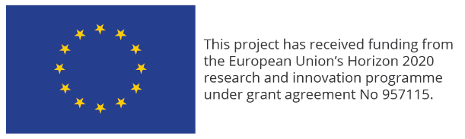
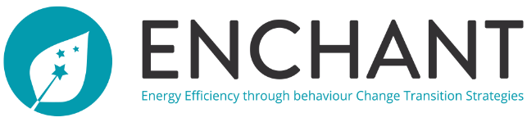

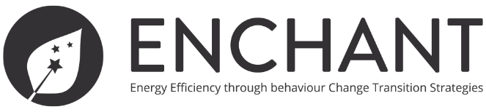

Acknowledge EU Funding:
As a beneficiary of funding from Horizon 2020, one of ENCHANT’s legal obligations is to acknowledge EU funding and display the EU emblem in all its information and communication material. That Horizon 2020 finances the project will be communicated throughout the project.

Basic rules for layout:
Layout
- The minimum height of the EU emblem shall be 1 cm.
- The name of the European Union shall always be spelled out in full.
- The typeface to be used in conjunction with the EU emblem can be any of the following: Arial, Calibri, Garamond, Trebuchet, Tahoma, Verdana.
Italic and underlined variations and the use of font effects are not allowed.
- The positioning of the text in relation to the EU emblem is not prescribed in any particular way but the text should not interfere with the emblem in any way.
- The font size used should be proportionate to the size of the emblem.
- The colour of the font should be reflex blue (same blue colour as the EU flag), black or white depending on the background.

We have developed guidelines for publicity and logo use, as well as templates for reports and presentations. By encouraging all partners consequently to employ project-templates and logos, these rules are more likely to be followed. The templates all include a project-logo, a joint EU-logo and disclaimer for use. Guidelines, templates and logos are accessible for all project partners on the Teams-site (Enchant/WP7/Enchant_logos-templates) used for internal communication, sharing files and documents, as well as arranging digital meetings.

Distribution of responsibilities
All partners of the consortium will actively contribute to dissemination and communication activities.
Partner responsibilities
- Identify and promote opportunities (e.g. scientific events, publications, etc.);
- Provide updates on their research achievements to ensure visibility on the project website and social media channels;
- Disseminate and communicate project information through their contacts within networks;
- Present the project at relevant conferences, workshops and other events;

The project coordinator is the central contact point for internal communication, while WP7 leader NTNU SR coordinates external communication and dissemination.

Message and terms
The relatively complex research setup, the many user-partner and their central role, means we have to be thorough and consistent in our communication. This implies defining, explaining and communicating concepts like ‘intervention’, ‘bias’, ‘randomised control trial’ and others. The written versions are accompanied by illustrations and examples of various expressions. We have also made an amination explaining RCT. Where needed, we will translate content to the individual country’s language.

https://ec.europa.eu/eurostat/statistics-explained/index.php/Energy_consumption_in_households#Energy_products_used_in_the_residential_sector
https://www.sum.uio.no/english/include/index.html
https://www.ducky.eco/en/
Ask any colleague.

